Roshan Tapas Basu

15BCE0837

Sequential Circuit II

Q1) Design and implement an asynchronous decade counter.

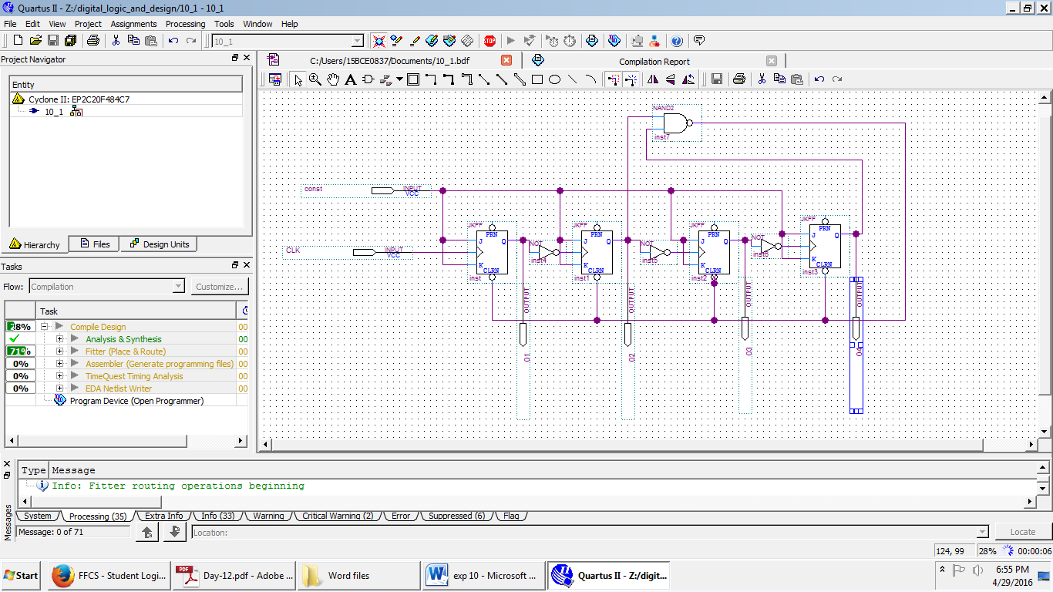

OUTPUT

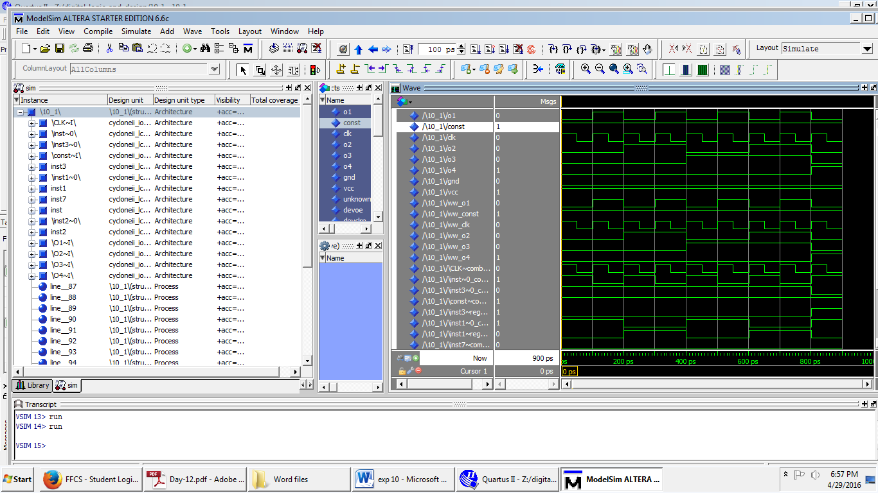

Q2) Transfer the contents of register ‘A’ to register ‘B’ in a serial manner using shift

registers. The contents of the register ‘A’ need to be retained.

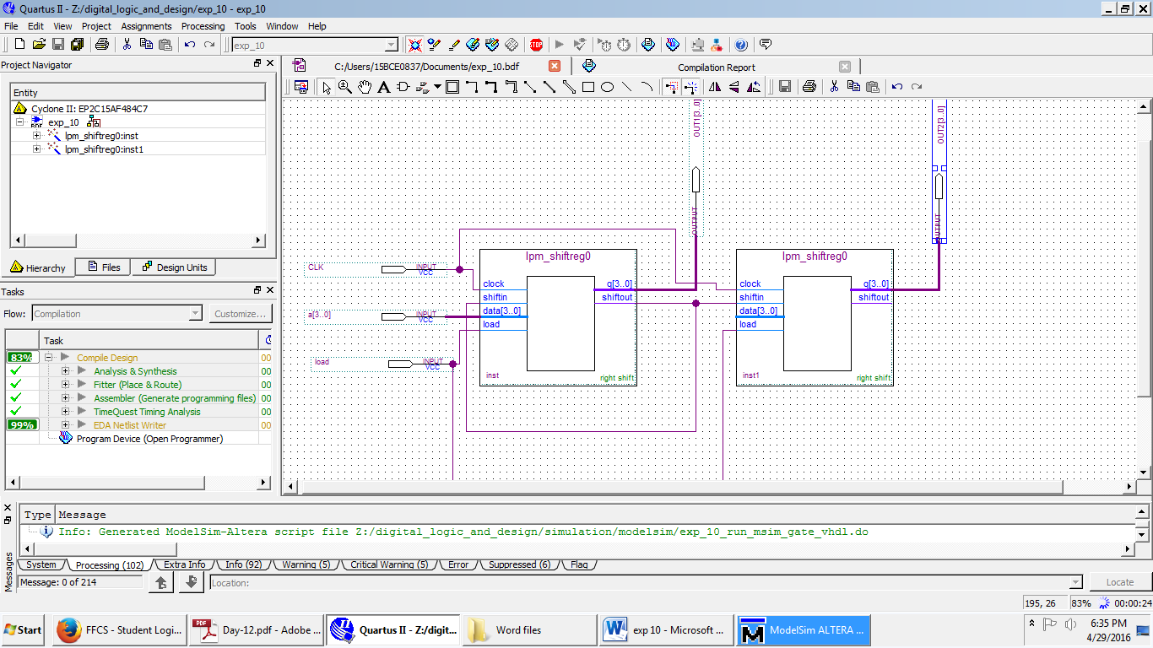

OUTPUT

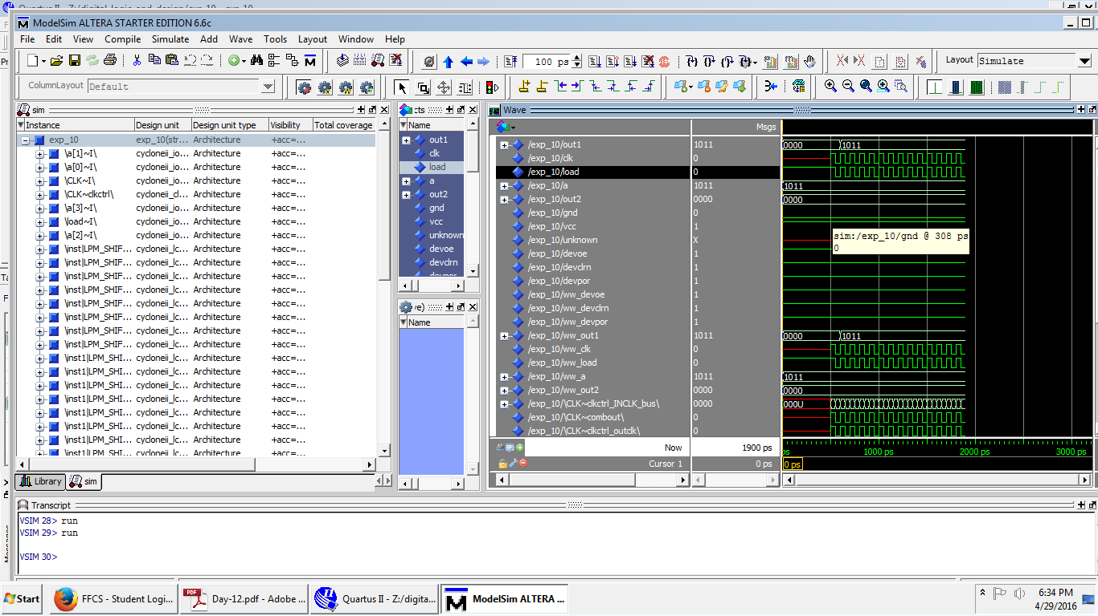

Q3) Design and implement four bit Johnson counter.

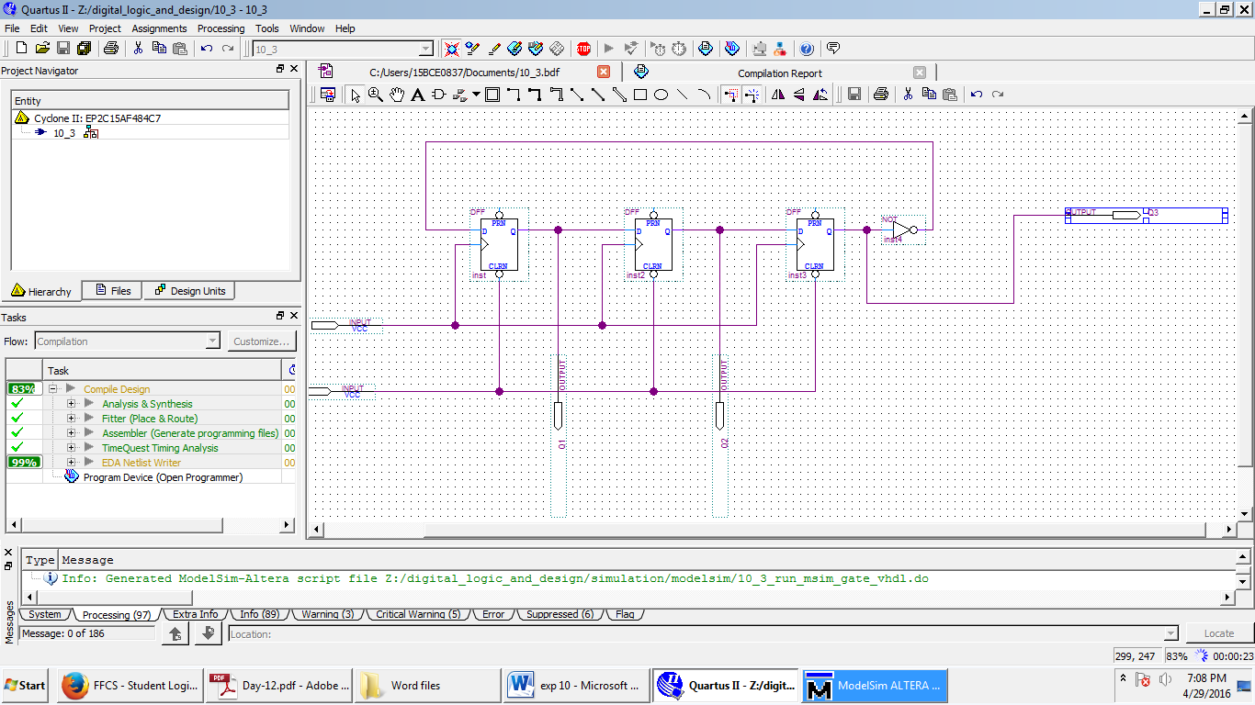

OUTPUT

